PE and Health Curriculum Ambition
Our Physical Education (PE) and Health curriculum will provide young people with the motivation, confidence, physical competence, knowledge, and understanding to value and engage in physical activities for life.
Our PE and Health curriculum is underpinned by three strands: Fit to Perform, Fit to Lead and Fit for Life.
Fit to Perform: Students will learn the skills and tactics required to be an effective performer in a wide range of physical activities. Students will develop their motor competence, decision-making and problem-solving capacities across a variety of physical activities.
Fit to Lead: Such is our commitment to developing generic leadership/employability skills in young people, students will enhance their communication, problem solving and organisational skills throughout the curriculum. Students will be supported in developing aspects of character, such as resilience, optimism and self-awareness that, with skilful reinforcement, can transfer into their academic life and endure into adulthood.
Fit for Life: Students will learn how to develop their physical, mental and social well-being throughout their fitness-based lessons. In addition, students will learn appropriate elements of sports science such as principles of training, training methods, basic functional anatomy, and diet and nutrition. These key concepts will provide students with the knowledge and understanding of how to plan, implement and monitor a physical activity programme for themselves. The theoretical knowledge developed at KS3 will also enable students to be successful if they choose a GCSE PE course (or equivalent) at KS4.
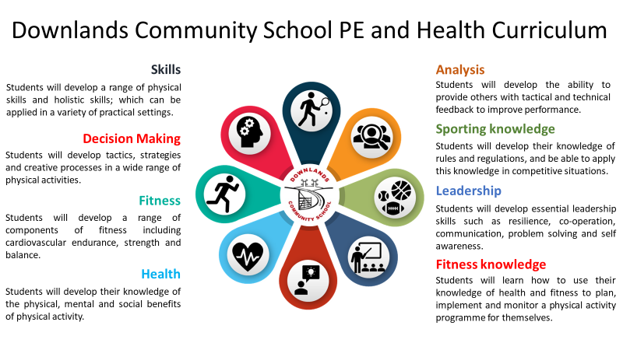

In Key Stage 3 students will build on and embed the physical development and skills learned in Key Stages 1 and 2, become more competent and confident in their techniques, and apply them across different sports and physical activities. All students will take part in a broad and inclusive curriculum, including 12 different physical activities per year. The students will experience a personalised and meaningful PE curriculum that focusses on developing motor competence, fun, personally relevant learning, appropriate challenge and social interaction (Fletcher et al., 2021). The students will participate in a PE curriculum in which their thoughts, feelings and interests have been carefully considered.
The students will understand what makes a performance effective and how to apply these principles to their own and others’ performances. They will begin to develop the confidence and motivation to participate in exercise, sports and activities out of school and in later life. The students will understand and apply the long-term health benefits of physical activity.
Throughout the curriculum students are constantly asked how to outwit opponents; evaluate performances; analyse strengths and weaknesses; whilst developing, adapting and refining skills, strategies and tactics to produce high levels of performances and high-quality techniques.
Students should be able to recognise the benefits of and engagement within sport, develop character and the competence to excel in a broad range of physical activities, are physically active for sustained periods of time and lead healthy, active lives.
As part of our PE curriculum and extra-curricular programme, we invest time into developing leaders. The students are provided with ample opportunities to lead within lessons and at our primary school SSCO festivals. A wide range of students will lead primary school events which will develop lifelong skills including organisation, confidence and self-awareness. Furthermore, this provides fantastic community links with all our local schools including students, parents and teachers.
The KS4 core PE curriculum is personalised for each class to create meaningful experiences to further develop a lifelong love for physical activity. Students will develop the confidence and motivation to take ownership over the types of physical activities that they participate in post-16.
Students will build upon their techniques and problem-solving capacities learned at KS3 and demonstrate more advanced and complex skills and tactics throughout the curriculum. Students will develop an understanding of the importance that exercise has on their physical, mental and social well-being.
If studying a KS4 PE course, students will develop and apply knowledge of sport related activities. They will explore contemporary issues, the impact of sport on the wider society and ways of being involved in the sporting industry. Students will also develop a deeper understanding of applied anatomy and physiology, and sports psychology.
The knowledge developed throughout the KS4 PE courses will enable students to progress onto post-16 college/sixth form courses such as A Level PE, Level 3 BTEC Sport and Exercise Science, and Level 3 BTEC Sport.
The PE and Dance department offer a very extensive and well-attended extra-curricular programme. Students will be provided with a variety of competitive and non-competitive opportunities to enhance their passion and interest for sporting activities. All students have the potential to compete in intra-school and inter-school competitions in a wide range of activities. Extra-curricular activities provide students with the ability to develop social skills and leadership characteristics.

